Statistics 2 : Probability

Task

**Part 1 :**

**FAQs on Discrete Random Variable**

Q1: What are Discrete Random Variables?

Q2: What is a Probability Distribution?

Q3: What is Expected Value?

Q4: What is Variance?

Q5: What is the Difference between Bernoulli Distribution and Binomial Distribution?

**Part 2 :**

1. **Find The mean or the expectation of the random variable X:**

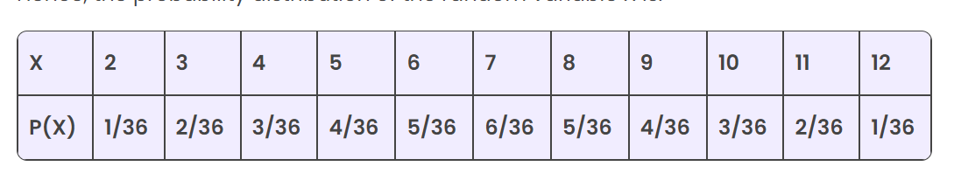

1. **Find the variance and standard deviation of the following probability distribution table**

| X | 0 | 1 | 2 | 3 |
| --- | --- | --- | --- | --- |
| P(X) | 0.1 | 0.2 | 0.4 | 0.3 |

Note: In both cases $σ^{2}=E\left[X^{2}\right]-{\left(E[X]\right)}^{2}$

Note: The population standard deviation $σ=\sqrt{σ^{2}}$

**Part 3 :**

**Classify each  random variable as either discrete or continuous and why.**

1. The number of arrivals at an emergency room between midnight and 6:00a.m6:00a.m.
2. The weight of a box of cereal labeled “1818 ounces.”
3. The duration of the next outgoing telephone call from a business office.
4. The number of kernels of popcorn in a 11-pound container.
5. The number of applicants for a job.
6. The time between customers entering a checkout lane at a retail store.
7. The weight of refuse on a truck arriving at a landfill.
8. The number of passengers in a passenger vehicle on a highway at rush hour.
9. The number of clerical errors on a medical chart.
10. The number of accident-free days in one month at a factory.